Milestone 1
Low Fidelity Sketch:
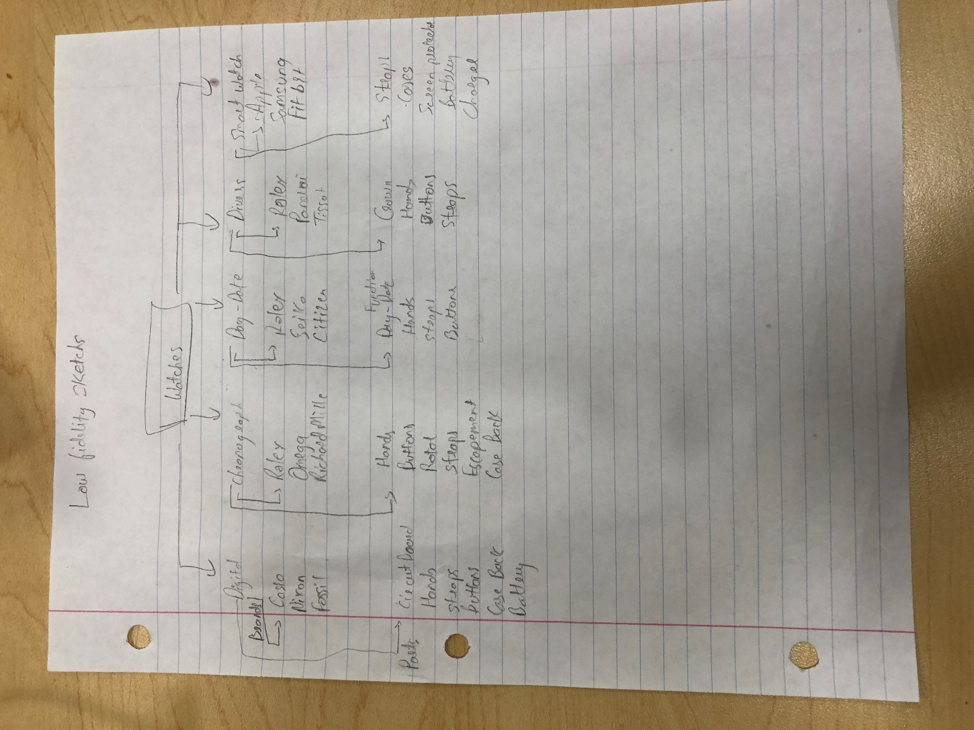
Properties:
- Digital (string)Digital watch is made for working class people in the military
- Chronograph (string)chronograph watch is made for timing events, racing, diving times
- Day date (string)the date function watch made for reading day date on an analog watch
- Divers (string)divers watch made for diving to deep distance is underwater
- Smart watch (string)smart watch created by smart Phone companies for people with iPhone or a Samsung Phone or for people into fitness.
- Circuit board (String) for digital watches and apple watches
- Hands (String) hands on the watch that show the time
- Straps (String) straps for the watches in different materials
- Buttons (String) buttons aka pushers for watches to change function or activate a new function
- Case back (String) case back to close the movement of the watch
- Battery (String) to power the digital and smart watches
- Rotor (String) winds the watch automatically so that it keeps running
- Escapement (String) keeps good oscillations so the watch hands move perfectly
- Day-date complication (String) it shows day and date on the watch
- Crown (String) how to change the time and other functions on the watch
- Cases (String) for smartwatches to be protected from debris and scratches
- Screen protector (String) to protect the screen of a smart watch
- Charger (String) to charge digital and smart watch.
- Brands (String) –
Casio
Nixon
Fossil
Rolex
Omega
Richard Mille
Seiko
Citizen
Panerai
Tissot
Apple
Samsung
FitBit

High Fidelity Sketch:
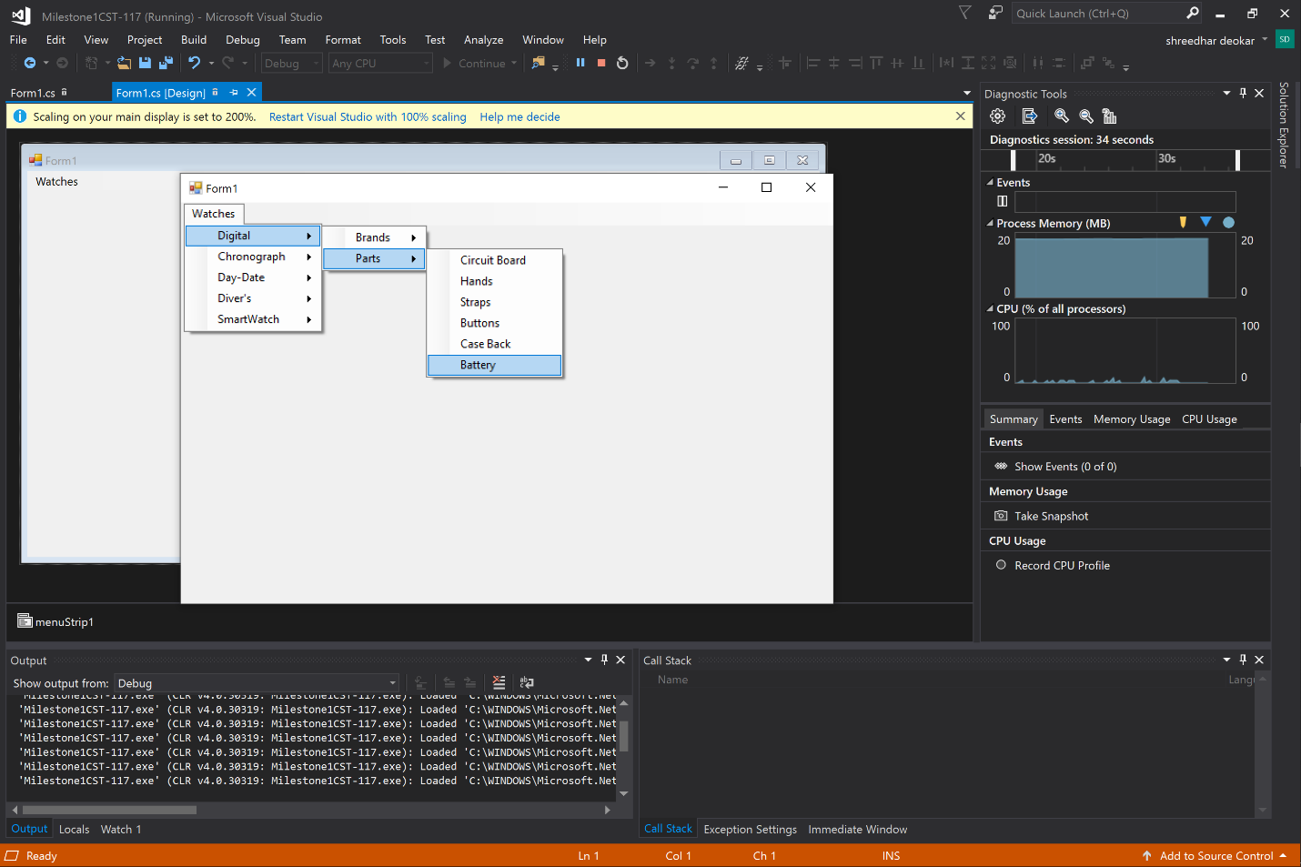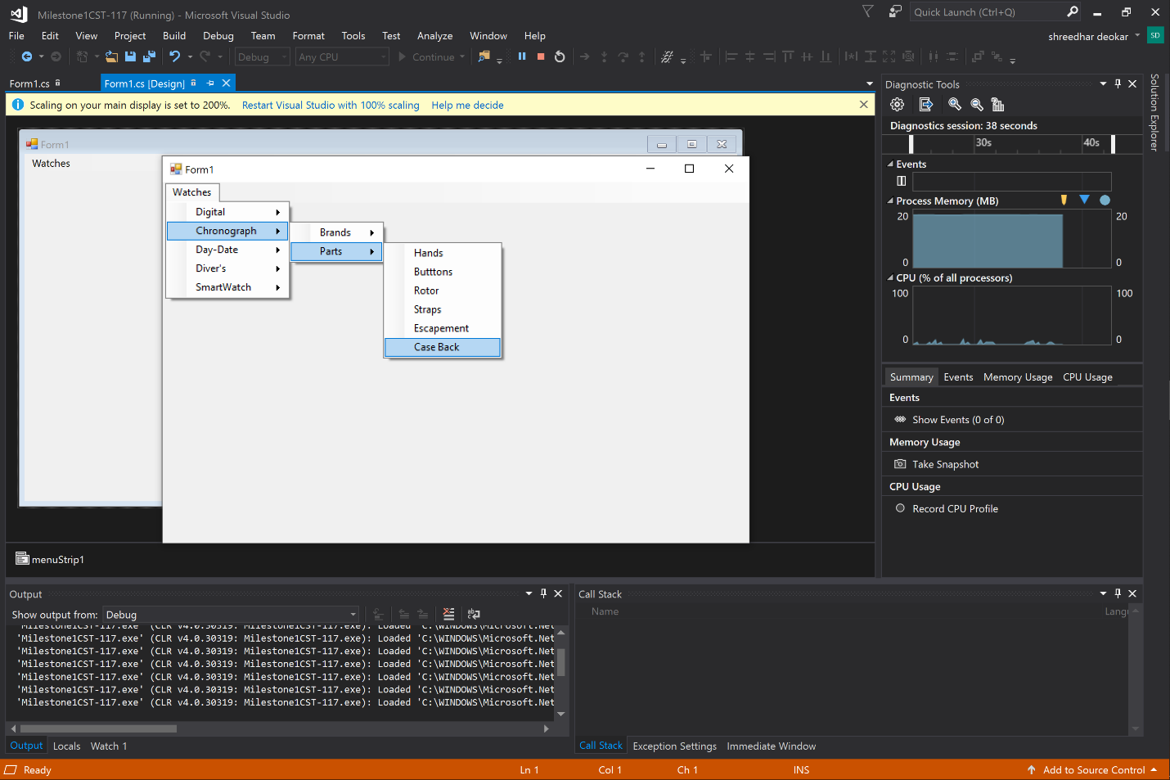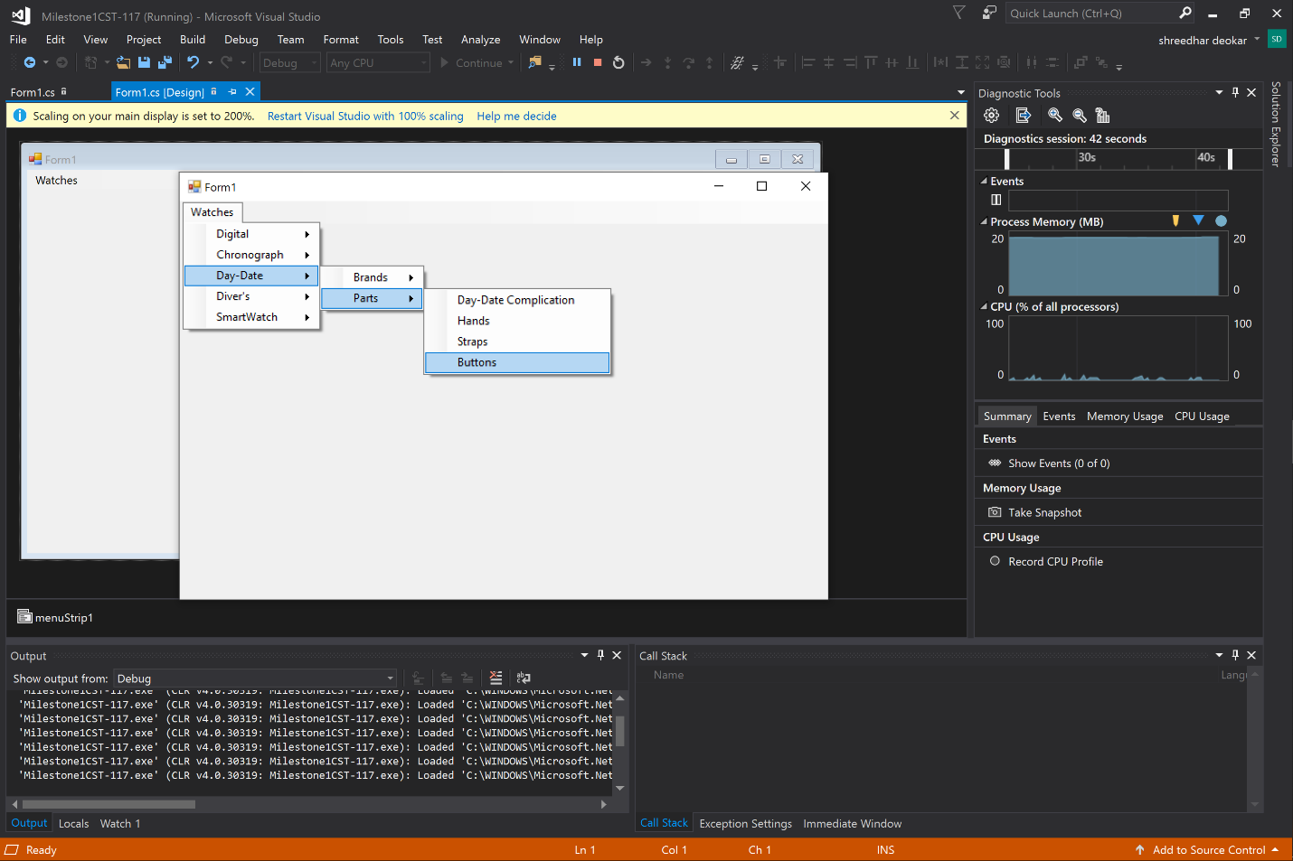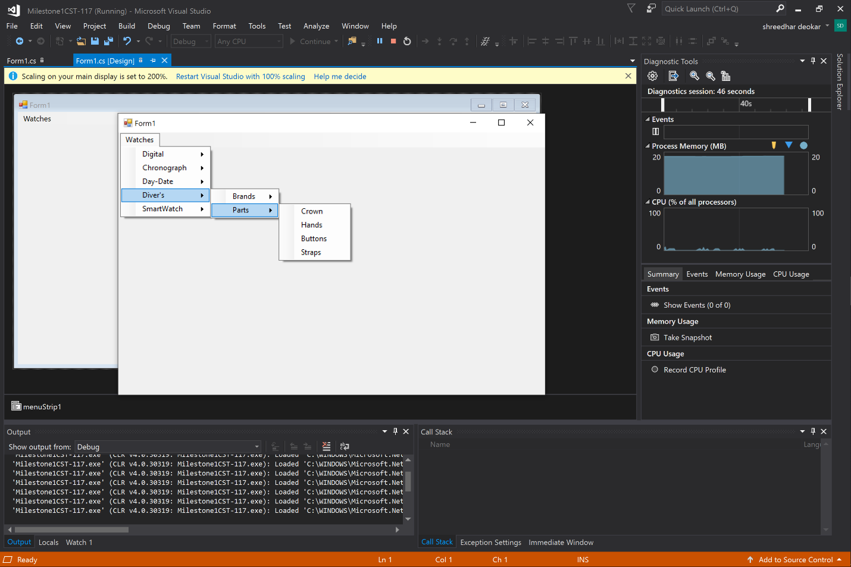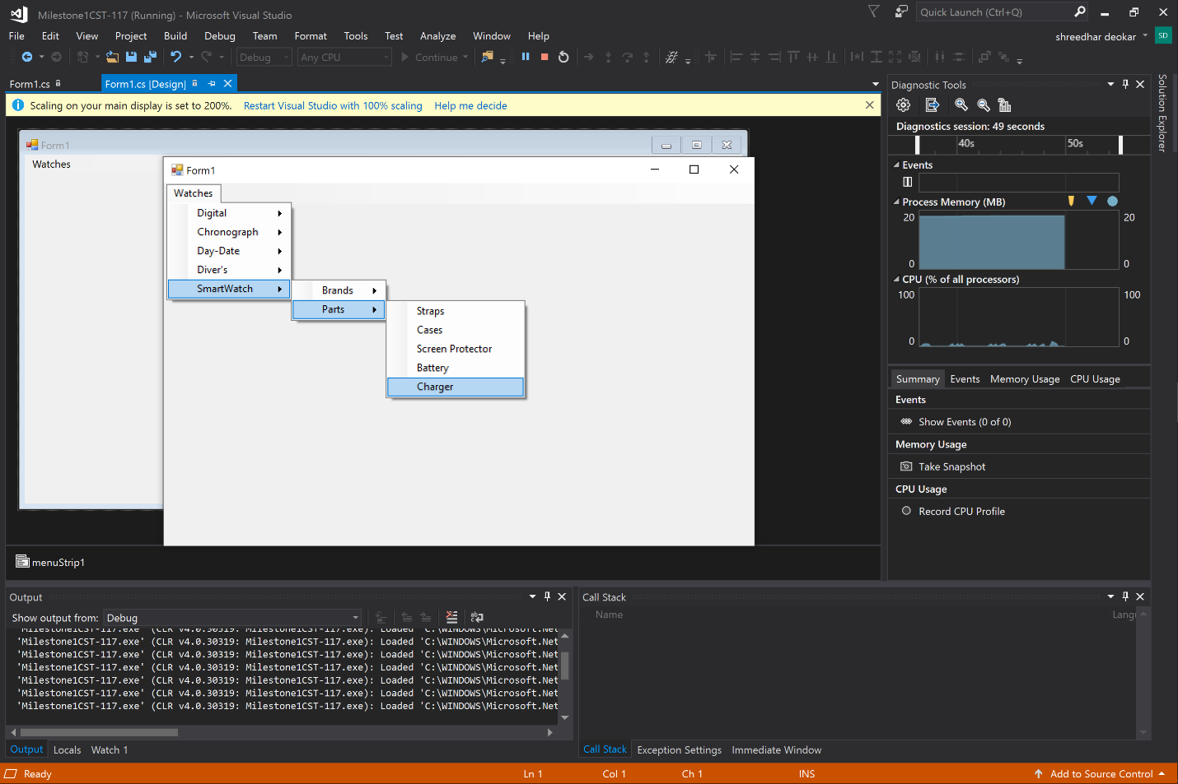

The Brands tab also has stuff in it, just would have been more too many screenshots.

